DAA LAB ASSIGNMENT – 5
Course: Design and Analysis of Algorithms (DAA)
Student Name: Lavanyadevi K
Register Number: CH.SC.U4CSE24226
Department / Class: B.Tech CSE – Section C (2nd Year)

Q1. Merge Sort

Question
Write a C program to sort a given set of elements using the Merge Sort algorithm.

Algorithm / Logic
- Divide the given array into two halves.
- Recursively apply merge sort on the left and right subarrays.
- Merge the two sorted subarrays into a single sorted array.
- Repeat until the entire array is sorted.
Merge Sort follows the divide and conquer approach.

C Program
#include <stdio.h>

void merge(int a[], int l, int m, int r) {
int i = l, j = m + 1, k = 0;
int temp[50];

while(i <= m && j <= r) {
if(a[i] < a[j])
temp[k++] = a[i++];
else
temp[k++] = a[j++];
}

while(i <= m)
temp[k++] = a[i++];

while(j <= r)
temp[k++] = a[j++];

for(i = l, k = 0; i <= r; i++, k++)
a[i] = temp[k];
}

void mergeSort(int a[], int l, int r) {
if(l < r) {
int m = (l + r) / 2;
mergeSort(a, l, m);
mergeSort(a, m + 1, r);
merge(a, l, m, r);
}
}

int main() {
int n, a[50];

printf("Enter number of elements: ");
scanf("%d", &n);

printf("Enter elements:\n");
for(int i = 0; i < n; i++)
scanf("%d", &a[i]);

mergeSort(a, 0, n - 1);

printf("Sorted array:\n");
for(int i = 0; i < n; i++)
printf("%d ", a[i]);

return 0;
}

Output

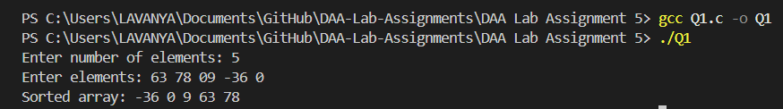

Interpretation
Merge Sort repeatedly divides the array into smaller subarrays and merges them in sorted order. It guarantees O(n log n) time complexity and is efficient for large datasets.

Q2. Quick Sort

Question
Write a C program to sort a given set of elements using the Quick Sort algorithm.

Algorithm / Logic
- Select a pivot element.
- Partition the array so that elements smaller than pivot are on the left and larger ones on the right.
- Recursively apply quick sort on left and right subarrays.
- Continue until the array is completely sorted.
Quick Sort is also based on the divide and conquer technique.

C Program
#include <stdio.h>

int partition(int a[], int low, int high) {
int pivot = a[low];
int i = low + 1;
int j = high;
int temp;

while(i <= j) {
while(a[i] <= pivot)
i++;
while(a[j] > pivot)
j--;
if(i < j) {
temp = a[i];
a[i] = a[j];
a[j] = temp;
}
}

temp = a[low];
a[low] = a[j];
a[j] = temp;

return j;
}

void quickSort(int a[], int low, int high) {
if(low < high) {
int p = partition(a, low, high);
quickSort(a, low, p - 1);
quickSort(a, p + 1, high);
}
}

int main() {
int n, a[50];

printf("Enter number of elements: ");
scanf("%d", &n);

printf("Enter elements:\n");
for(int i = 0; i < n; i++)
scanf("%d", &a[i]);

quickSort(a, 0, n - 1);

printf("Sorted array:\n");
for(int i = 0; i < n; i++)
printf("%d ", a[i]);

return 0;
}

Output

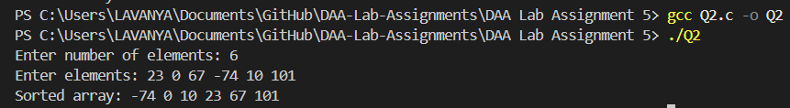

Interpretation
Quick Sort works by selecting a pivot and partitioning the array around it. It is very fast in practice, with an average time complexity of O(n log n).

Q3. Binary Search Tree (BST)

Question
Write a C program to implement Binary Search Tree operations and perform inorder traversal.

Algorithm / Logic
- Insert elements into the BST such that:
  - Left child < root
  - Right child > root
- Use inorder traversal to display elements in sorted order.
- Recursively traverse left subtree, root, then right subtree.

C Program
#include <stdio.h>
#include <stdlib.h>

struct node {
int data;
struct node *left, *right;
};

struct node* create(int val) {
struct node* temp = (struct node*)malloc(sizeof(struct node));
temp->data = val;
temp->left = temp->right = NULL;
return temp;
}

struct node* insert(struct node* root, int val) {
if(root == NULL)
return create(val);
if(val < root->data)
root->left = insert(root->left, val);
else
root->right = insert(root->right, val);
return root;
}

void inorder(struct node* root) {
if(root != NULL) {
inorder(root->left);
printf("%d ", root->data);
inorder(root->right);
}
}

int main() {
struct node* root = NULL;
int n, val;

printf("Enter number of nodes: ");
scanf("%d", &n);

printf("Enter values:\n");
for(int i = 0; i < n; i++) {
scanf("%d", &val);
root = insert(root, val);
}

printf("Inorder traversal:\n");
inorder(root);

return 0;
}

Output

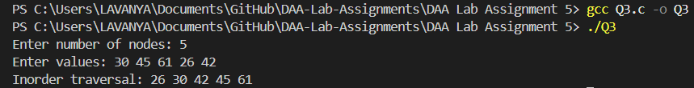

Interpretation
A Binary Search Tree stores data in an ordered manner. Inorder traversal of a BST always produces elements in sorted order, making it useful for searching and sorting operations.

